NEVADA COMMISSION for the RECONSTRUCTION of the V&T RAILWAY

THURSDAY, March 26, 2020 @ 1:00pm

Carson City Community Center – SIERRA ROOM
851 East William Street (Highway 50 and South Roop Street) Carson City, Nevada 89701

AGENDA

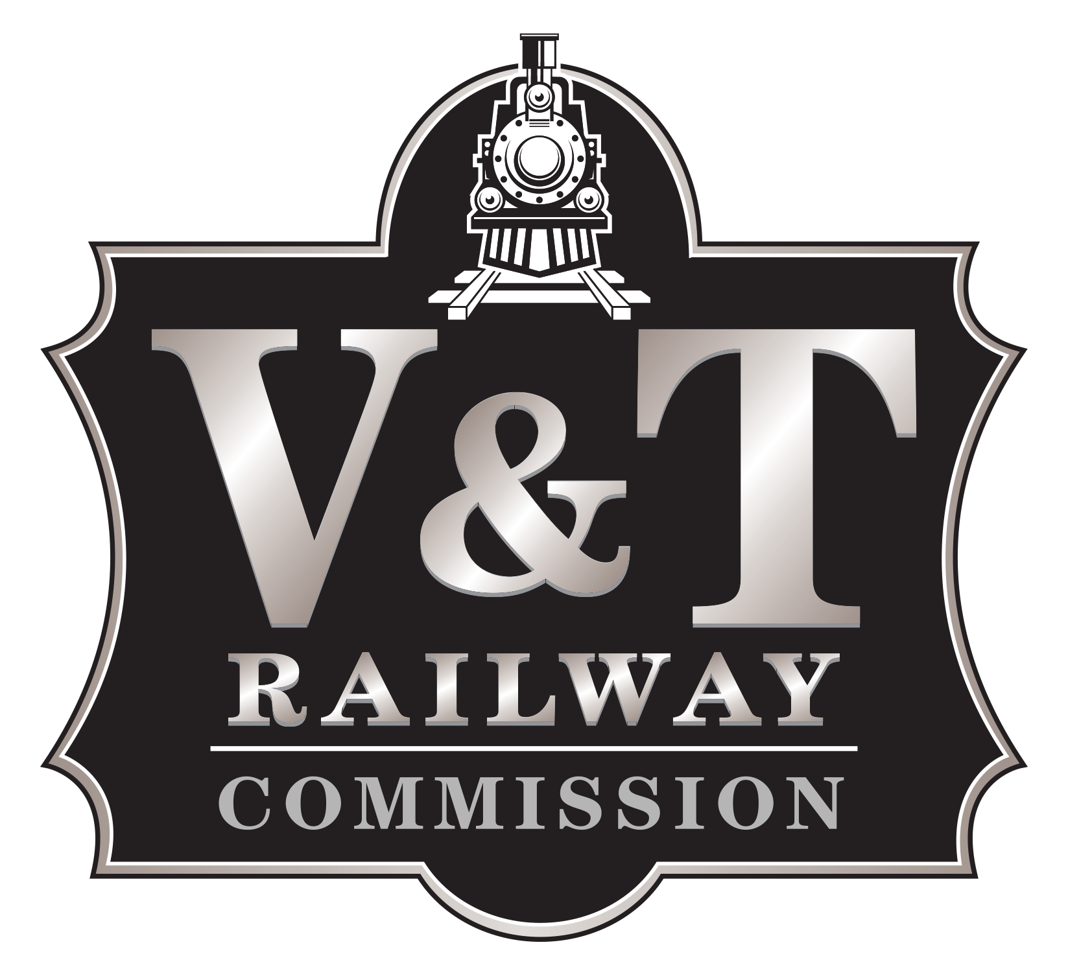

Public Notice: Meeting Cancellation

MARCH 26, 2020 MEETING IS CANCELLED

The March 26, 2020 V&T Railway Commission meeting has been cancelled.
V&T Railway is taking precautionary measures to reduce public gatherings and promote social distancing as recommended by the CDC and the State of Nevada.

