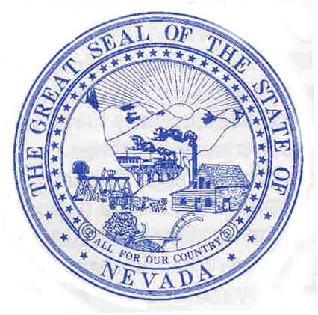
State of Nevada

CO COMMISSION FOR THE RECONSTRUCTION OF THE V&T RAILWAY
P.O. Box 1711
Carson City, Nevada 89702

Steve Sisolak Stan Jones
Governor FY20 & FY21 Chairman

Requests for Funds

August 27, 2020

Dear Mr. Osborne and Ms. McCain,

The V&T Railway Commission respectfully requests the annual contribution of $250,000 as stipulated in the new V&T Interlocal Agreement with Storey County for fiscal year 2021. As per the new agreement, Storey County will assign $250,000.00 annually from the proceeds of the sales tax in the V & T Railway Fund for operational costs and maintenance of the track within Storey County.

Although, the Summer steam train season was cancelled by the V&T Commission due to the COVID-19 pandemic, our plans are to work on track projects during the downtime and reopen for excursion train travel this Spring. All train ride requests that we have received have been referred to the short ride in Virginia City.

Regards,

Stan Jones
Chairman
V&T Railway Commission

Cc: Deny Dotson, V&T Railway Commission Treasurer
Marshall McBride, Storey County Commission, Chairman

