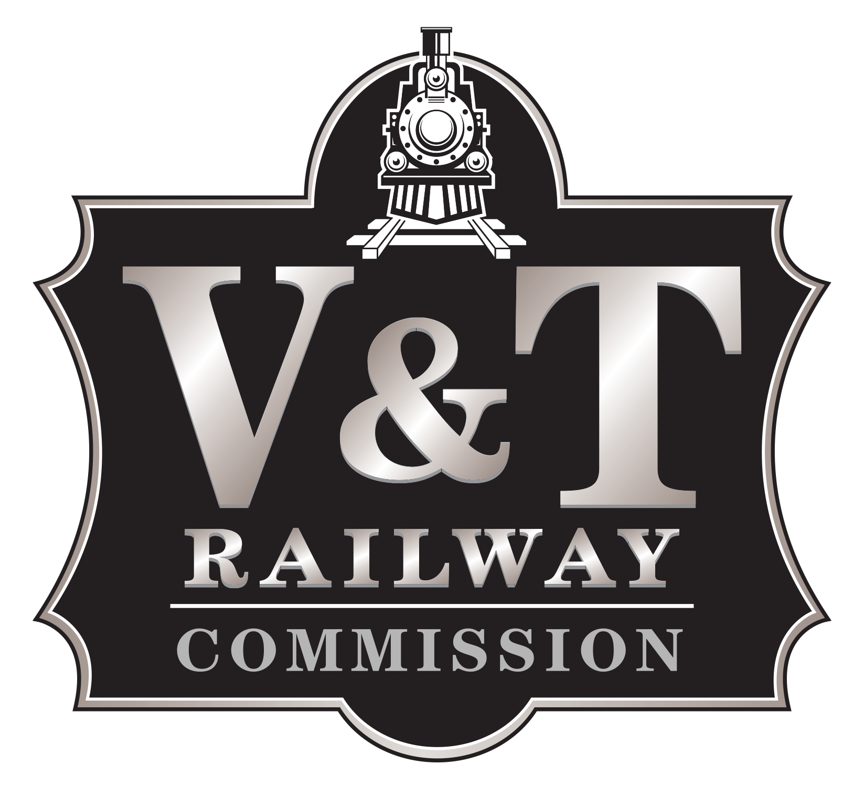
Commission Members

Deny Dotson
Stephanie Hicks
Clay Mitchell
David Peterson
Jim Wells

Corrected
NOTICE OF PUBLIC MEETING

NEVADA COMMISSION for the RECONSTRUCTION of the V&T RAILWAY (“V&T Railway Commission”)

DAY: Wednesday
DATE: January 26, 2022
TIME: 9:00 am
LOCATION: Carson City Community Center Robert “Bob” Crowell Board Room
851 E. William St.
Carson City, NV 89701

AGENDA
NOTICE TO THE PUBLIC
The State of Nevada and Carson City are currently in a declared State of Emergency in response to the global pandemic caused by the coronavirus (COVID-19) infectious disease outbreak. In accordance with the applicable Directives issued under authority of the Governor’s Declaration of Emergency, including Directive 045 and 047, and subject to any potential changes in state or federal mandates or guidelines, face coverings are required to be worn when attending this meeting in person.
Members of the public who wish only to view the meeting but do NOT plan to make public comment may watch the livestream of the V&T Railway Commission meeting at www.carson.org/granicus and by clicking on “In progress” next to the meeting date, or by tuning in to cable channel 191. Livestream of the meeting is provided solely as a courtesy and convenience to the public. Carson City does not give any assurance or guarantee that the livestream or cable channel access will be reliable. Although all reasonable efforts will be made to provide livestream, unanticipated technical difficulties beyond the control of City staff may delay, interrupt or render unavailable continuous livestream capability.
The public may provide public comment in advance of a meeting by written submission to the following email address: admin@vtrailway.com. For inclusion or reference in the minutes of the meeting, your public comment must include your full name and be submitted via email by not later than 3:00 p.m. the day before the meeting.
Members of the public who wish to provide live public comment via telephonic appearance in lieu of physical attendance may do so during the designated public comment periods indicated on the agenda by dialing the numbers listed below. Please do NOT join by phone if you do not wish to make public comment.
Join by phone:
Phone Number: +1-408-418-9388
Meeting Number: 2493 342 4989
- CALL TO ORDER

- ROLL CALL AND DETERMINATION OF A QUORUM

- pLEDGE OF ALLEGIANCE

- PUBLIC COMMENT:** The public is invited at this time to comment on and discuss any topic that is relevant to or within the authority of this public body.

- for possible action: Approval of Minutes of the November 11 30, 2021, meeting.

Consent Agenda

All matters listed under the consent agenda are considered routine and may be acted upon by the V&T Railway Commission (V&T) with one action and without an extensive hearing. Any member of the commission may request that an item be taken from the consent agenda, discussed and acted upon separately during this meeting. The chairman or the vice chairman retains discretion in deciding whether or not an item will be pulled off the consent agenda.

- FOR POSSIBLE ACTION: Discussion and possible action regarding approval of the V&T statement of accounts payable checks paid November 1 – December 31, 2021. – Jim Wells (admin@vtrailway.com) Staff summary: The V&T Commission will review the invoice listing for accounts payable checks totaling $181,881.88, paid November 1 – 30, and $98,800.94, paid December 1 - 31, 2021.

- FOR POSSIBLE ACTION: Discussion and possible action regarding approval of the adjusted V&T FY21/22 budget report, period ending December 31, 2021. – Jim Wells (admin@vtrailway.com) Staff summary: The V&T Commission will review a comparative statement of adjusted revenue totaling $1,021,229.50, expenses totaling $485,746.40 and make a determination whether they approve of the report.

(End of Consent Agenda)

- Item(s) pulled from the Consent Agenda will be heard at this time.

- FOR POSSIBLE ACTION: Discussion and possible action regarding proposal from Gabe Willaman Railroad Construction in response to Request for Proposal 2021-26 Track Maintenance Services. – David Peterson (dpeterson@visitcarsoncity.com) Staff summary: V&T Railway Commission posted Request for Proposal 2021-26 Track Maintenance Services on November 15, 2021. Gabe Willaman Railroad Construction was the single bidder.

- FOR discussion only:

MONTHLY NON-ACTION ITEMS:
- Operations Report – Allyson Bolton
- Attorney’s Report – Michael Rowe
- Engineer’s Report – Ken Dorr
- Upcoming Meeting: The next V&T Commissioner’s meeting is tentatively scheduled for February 23, at 9:00 am.

- Commissioner Comments or Announcements, and Requests for Information: No action will be taken and no discussion among the members or with staff will take place during this item of the agenda.

- PUBLIC COMMENT: The public is invited at this time to comment on any matter that is not specifically included on the agenda as an action item. No action may be taken on a matter raised under this item of the agenda.

- For possible action: To Adjourn.

**PUBLIC COMMENT LIMITATIONS – The V&T Railway Commission will provide at least two public comment periods in compliance with the minimum requirements of the Open Meeting Law prior to adjournment. Public comment will be taken at the beginning of the agenda before any action is taken and again at the end before adjournment. No action may be taken on a matter raised under public comment unless the item has been specifically included on the agenda as an item upon which action may be taken. The Chair may call for or allow additional individual-item public comment at the time of the body’s consideration of the item when: (1) the comment will be provided from a person who is directly involved with the item, such as V&T staff or an applicant; or (2) it involves any person’s or entity’s due process appeal or hearing rights provided by statute or the Carson City Municipal Code. Comments may be limited to three minutes per person or topic at the discretion of the Chair in order to facilitate the meeting.

Agenda Management Notice - Items on the agenda may be taken out of order; the public body may combine two or more agenda items for consideration; and the public body may remove an item from the agenda or delay discussion relating to an item on the agenda at any time.

Titles of agenda items are intended to identify specific matters. If you desire detailed information concerning any subject matter itemized within this agenda, you are encouraged to call the V&T Railway Commission. You are encouraged to attend this meeting and participate by commenting on any agendized item.

Notice to persons with disabilities: Members of the public who are disabled and require special assistance or accommodations at the meeting are requested to notify the V&T Railway Commission in writing at PO Box 1711, Carson City, NV, 89702, or by calling (775) 686-9037 at least 24 hours in advance.

To request a copy of the supporting materials for this meeting, contact Allyson Bolton at admin@vtrailway.com or call (775) 686-9037.

The agenda and supporting material are available on the V&T Railway Commission website: https://vtrailway.com/about/vt-commission/ and at the office of the Carson City Culture & Tourism Authority dba Visit Carson City - 716 North Carson Street, Carson City, Nevada.

If a person willfully disrupts a meeting, to the extent that its orderly conduct is made impractical, the person may be removed or excluded from the meeting. NRS 241.030(4).

This notice has been posted at the following locations:
Office of Visit Carson City, 716 North Carson Street
https://vtrailway.com/about/vt-commission/
http://notice.nv.gov

